
The University Of Azad Jammu & Kashmir,Muzaffarabad
Name: Muqaddas Kiani
Roll NO: 2024-SE-23
Course Code: CS-2203
Submission Date:12thMarch,2026
Course Title:Computer Networks
Instructor Name: Engr. Asma Javaid

Department Of Software Engineering
LAB TASK 03 – Ethernet Cable Making & Testing
An Ethernet cable is a type of wired network cable used to connect devices like computers, routers, and switches to a local network (LAN) or the internet.
It transfers data between devices—basically giving you a stable and fast internet connection compared to Wi-Fi.

Objective
The objective of this lab task was to:
- Learn how to construct an Ethernet cable using proper wiring standards
- Understand the use of RJ-45 connectors
- Test the cable using a network cable tester
- Verify whether the cable is properly working or not

Materials Required
- Ethernet Cable (UTP Cable)
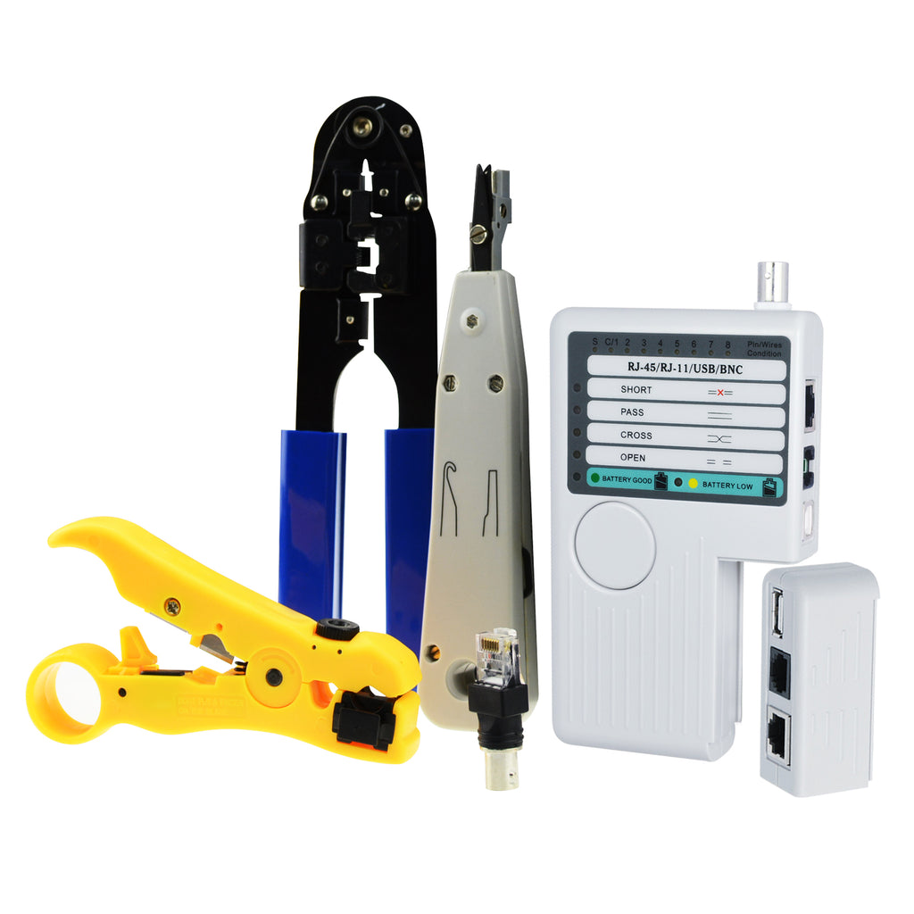
- RJ-45 Connectors
- Crimping Tool
- Cable Cutter/Stripper
- Cable Tester (RJ-45/RJ-11/USB/BNC tester)

Procedure

1. Cable Preparation
First, the outer insulation of the Ethernet cable was carefully removed using a cable stripper. Inside, 8 colored wires were exposed.

2. Wire Arrangement (Standard)
The wires were arranged according to the T568B wiring standard, which is commonly used.
T568B Color Order:
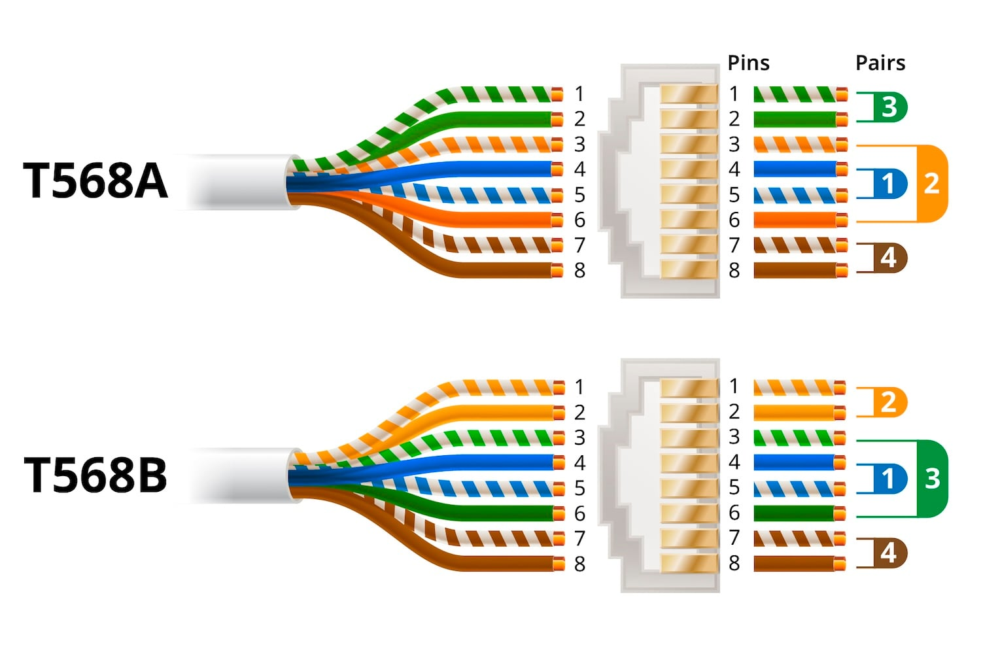
- White-Orange
- Orange
- White-Green
- Blue
- White-Blue
- Green
- White-Brown
- Brown

3. Inserting into RJ-45 Connector
- The arranged wires were straightened and cut evenly
- Inserted into the RJ-45 connector carefully
- Ensured all wires reached the end properly

4. Crimping
- The connector was inserted into the crimping tool
- Pressed tightly to fix the wires inside the connector

5. Repeating for Other End
The same process was repeated on the second side of the cable.

6. Cable Testing
The cable was tested using a cable tester (as shown in the image).

Observation from Tester:
- The LED lights from 1 to 8 turned on sequentially
- The CONNECTED light was ON (blue light)
- No indication of:
  - Short circuit ❌
  - Non-parallel wiring ❌
  - No connection ❌

Result
The Ethernet cable was successfully constructed and tested.
All pins were properly connected, and the cable is fully functional and working correctly.

Conclusion
This lab activity helped in understanding the practical process of making an Ethernet cable. It also improved knowledge about wiring standards and the use of cable testers. The successful testing confirmed that the cable was properly assembled without any faults.

Precautions
- Ensure correct wire color order
- Cut wires evenly before inserting
- Push wires fully into connector
- Crimp properly to avoid loose connections
- Always test cable after making

Learning Outcome
- Learned Ethernet cable construction
- Understood T568B standard
- Gained hands-on experience with crimping tool
- Learned how to use a cable tester
My Work;
